**High Level Design (HLD)**

**Money Laundering Prevention System**

**Written By: Mukul Palmia**

Table of Contents

1. Introduction
2. System Architecture
3. User Interface
4. Application Server
5. Machine Learning Model
6. Database
7. Documentation and Collaboration
8. Conclusion

**1. Introduction**

Money laundering is a critical financial crime that involves the concealment of illegally obtained funds to make them appear legitimate. This project aims to develop a **Money Laundering Prevention System (MLPS)** using **machine learning techniques** to detect and prevent fraudulent financial transactions. By analyzing historical transaction data and identifying suspicious patterns, financial institutions can take proactive measures to mitigate risks and comply with anti-money laundering (AML) regulations.

This High-Level Design (HLD) document outlines the architecture, components, and functionalities of the system to ensure a structured and efficient development process.

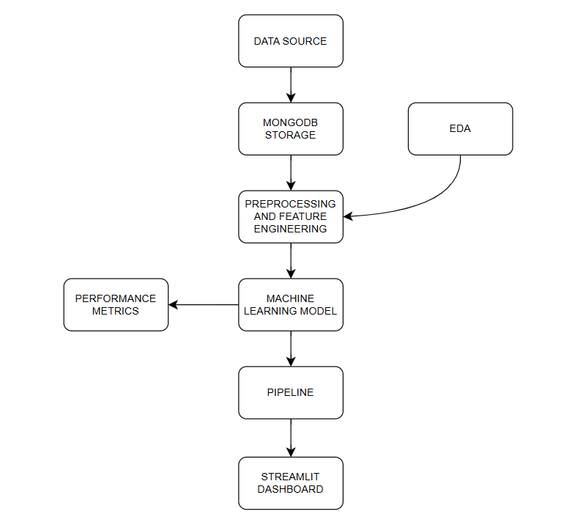

**2. System Architecture**

The **Money Laundering Prevention System** is designed with a modular architecture to facilitate scalability, maintainability, and security. The core components of the system are:

* **User Interface (UI)** – A web-based or desktop application that enables users to interact with the system.
* **Application Server** – The processing unit that handles data ingestion, transformation, model inference, and response generation.
* **Machine Learning Model** – An intelligent module that detects suspicious transaction patterns using supervised and unsupervised learning techniques.
* **Database** – A centralized data repository for storing transaction logs, predictions, and user-related information.

These components communicate seamlessly through APIs and data pipelines to ensure smooth functionality and real-time processing capabilities.

**3. User Interface**

The **User Interface (UI)** is the front-end component of the system, designed to provide a user-friendly experience. The key functionalities include:

* **Data Input:** Users can upload transaction records, enter details manually, or integrate with external banking systems.
* **Transaction Monitoring:** Provides real-time alerts and notifications for suspicious transactions.
* **Visualization Dashboard:** Displays insights, transaction trends, and flagged cases in an intuitive graphical format.
* **User Authentication:** Implements role-based access control (RBAC) to ensure secure usage.
* **Report Generation:** Allows users to export detailed reports on suspicious transactions and system analytics.

The UI interacts with the **Application Server** through API requests to process user input and retrieve results dynamically.

**4. Application Server**

The **Application Server** acts as the central processing unit, responsible for managing data flow between the UI, Machine Learning Model, and Database. The core responsibilities include:

1. **Data Ingestion:**
   * Receives transaction data from the UI or external financial APIs.
   * Validates the data integrity, ensuring completeness and correctness.
   * Handles missing or inconsistent values through data preprocessing techniques.
2. **Data Transformation:**
   * Performs feature engineering to extract meaningful attributes from raw transaction data.
   * Normalizes and encodes categorical variables to ensure compatibility with the ML model.
3. **Model Prediction:**
   * Forwards preprocessed data to the Machine Learning Model for inference.
   * Receives and interprets model predictions, classifying transactions as normal or suspicious.
4. **Data Persistence:**
   * Stores input data, processed features, and prediction results in the database for audit and analysis.
5. **User Notifications:**
   * Sends flagged transactions to the UI for display.
   * Generates alerts and detailed reports for financial institutions and compliance officers.

The **Application Server** ensures efficient, real-time processing of transactions to maintain the integrity and reliability of the system.

**5. Machine Learning Model**

The **Machine Learning Model** is the core intelligence of the **Money Laundering Prevention System**, responsible for detecting fraudulent activities based on historical transaction patterns. The model is trained using a dataset containing transaction details such as:

* **Transaction Amount** – The total amount transferred.
* **Transaction Type** – Cash-in, cash-out, wire transfer, etc.
* **Time of Transaction** – Timestamp of financial activity.
* **Sender & Receiver Details** – Account IDs and previous transaction history.
* **Transaction Frequency** – The number of transactions per user within a given timeframe.
* **Fraud Labels** – Labeled instances of suspicious or legitimate transactions.

**Machine Learning Techniques Used:**

* **Supervised Learning:**
  + Random Forest
  + Support Vector Machine (SVM)
  + Gradient Boosting Trees (XGBoost, LightGBM)
* **Unsupervised Learning:**
  + Anomaly Detection (Autoencoders, Isolation Forest)
  + Clustering (K-Means, DBSCAN) for detecting hidden fraud patterns

The model is periodically updated with new data to improve detection accuracy and adapt to emerging fraud tactics.

**6. Database**

The **Database** is a crucial component that stores and manages transaction records, predictions, and user data. The system uses **MongoDB**, a NoSQL database, for its flexibility, scalability, and ability to handle large transaction datasets efficiently.

**Database Structure:**

1. **Users Collection:** Stores authentication details and access permissions.
2. **Transactions Collection:** Records all financial transactions with timestamps, amounts, and other metadata.
3. **Fraud Predictions Collection:** Logs suspicious transactions flagged by the ML model.
4. **Audit Logs Collection:** Maintains a history of user actions and system responses for regulatory compliance.

The database ensures data persistence, retrieval efficiency, and security compliance with financial regulations such as **AML Compliance Standards and GDPR**.

**7. Documentation and Collaboration**

To facilitate system understanding, development, and maintenance, comprehensive documentation is maintained, including:

* **System Architecture Documentation:** Diagrams and flowcharts explaining system interactions.
* **Code Documentation:** Detailed explanations of functions, modules, and API endpoints.
* **Data Dictionary:** Descriptions of all data fields and their significance.
* **User Manuals:** Guides for financial analysts and compliance officers on using the system.
* **Development Repository:** Source code and version control using GitHub for collaboration.

Effective documentation ensures smooth onboarding for new developers, easy debugging, and future scalability.

**8. Conclusion**

The **High-Level Design (HLD) document** provides a structured blueprint for the **Money Laundering Prevention System**, outlining the core architectural components and their interactions.

By integrating a user-friendly interface, a robust application server, an intelligent machine learning model, and a scalable database, the system ensures efficient, real-time detection of suspicious financial transactions. The architecture is designed to be **modular, scalable, and secure**, allowing for continuous improvements and adaptability to evolving financial crime patterns.

This document serves as a foundational guide for developers, stakeholders, and compliance officers, ensuring a structured and coherent approach to the development, deployment, and maintenance of the system.